Never Lost
Tatiana Salcedo^{#1}
#Journalism and Media Studies Department, Lehman College
250 Bedford Park Boulevard West. Bronx, NY 10468. United States.
¹tatiana.salcedo@lc.cuny.edu

ABSTRACT
This document will solely focus on the use of the “Never Lost” phone application. This application is meant to help keep children from being kidnapped. The application works alongside a GPS tracked pin which can be attached to any and all kinds of materials. The application also works alongside the police department of your city.
Keywords
Phone application; GPS tracking; pin device

INTRODUCTION
Kidnappings date back to 1874 when two little boys were abducted in front of their family’s home. It was the first kidnapping for ransom in the history of the U.S [1]. Since then, numerous of kidnappings have unfortunately occurred. This application’s sole purpose is to bring down the number of children who are abducted.

GETTING STARTED
First and foremost, one must purchase our GPS tracking device which can be bought straight from our website NeverLost.com. Once your device has arrived, you can download the “Never Lost” phone application.

SETTING UP
Upon opening the app for the first time, you will see our logo and a button below it. You will click the button in order to set up your new device. Below the button, there is a log in option if you are already a customer and are just registering a new or additional phone to follow a previously purchased device.
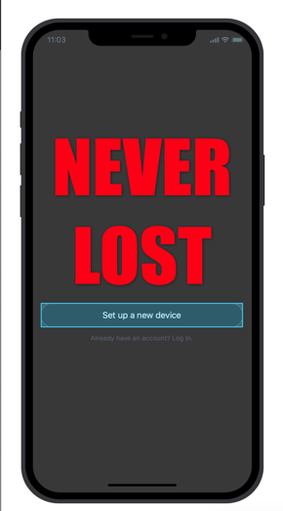
Figure 1. App home screen before registering a device.
You will then be instructed to add the device serial number to the app. The device serial number can be found on the back of the box that it came in.
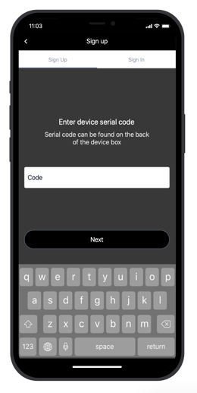
Figure 2. Entering device serial number to connect GPS tracking device

LOCATIONS
Now that the GPS tracked device is connected to your mobile device, you can choose your “Safe Spots.” You will enter the addresses of your safe spots and will be asked to enter a radial distance. You can enter up an infinite number of safe spots.
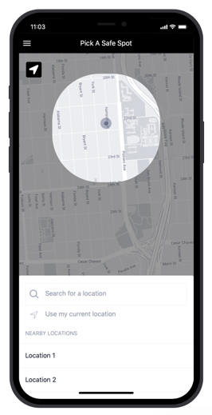
Figure 3. Safe Spots
An added location service that the application features is understanding that if the mobile device that is tracking the GPS tracked device is within 5 feet of the GPS tracked device in an unspecified location, there is no danger. Should the distance from both devices, then both devices will go into the emergency mode.
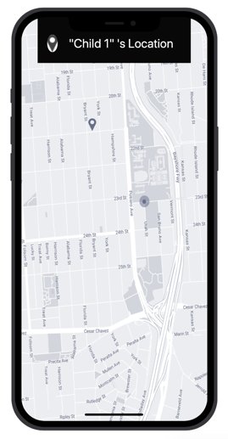
Figure 4. Live location of GPS tracked device

EMERGENCY MODE
Emergency mode is when the tracked device believes that the child wearing the device may be in imminent danger. The tracking device not only continues to send its location to the parent mobile device, but it will now send a message to your local police department. The message will include a live current location of the device and will state the name of the safe spot that the child has been removed from.
Emergency mode can be activated in multiple ways. The tracked device moving out of the radial distance of a safe spot is one of the ways emergency mode can be activated. Another way to activate emergency mode would be if the parent mobile device and the tracked device are more than 5 feet apart of each other in an unspecified location. These two emergency mode activations are done automatically. If you should want to enter emergency mode manually, you can open up you “Never Lost” mobile app and it there will be a big red button that says, “PUSH FOR EMERGENCY.” This button will send a live location of the tracked location to the police department and will also connect you with them through a phone call.
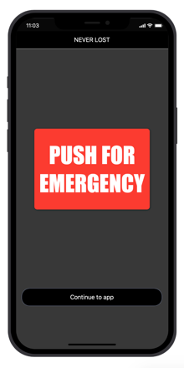
Figure 5. Home screen after all set up has been done

STATISTICS
Kidnapping is a serious problem in the United States. Nearly 800,000 children are reported missing yearly which is more than 2,000 children a day [2]. These numbers were reported by the National Center for Missing and Exploited Children. Children are considered missing for many different reasons. Only 115 children are victims of what most people would identify as kidnapping. 57% of the 115 children end up back in the hands of their parents. Unfortunately, the other 43% isn’t so lucky. We are here to help 100% of children stay safe, whether they are part of the stereotypical kidnapping (by a stranger) or another form of kidnapping.

Who Goes Missing in New York?
People in NYC reported (2014) | Reports per day in NYC | Reports of children in NYC (2013) | Children missing in NYC (2013) | Vulnerable adults reported (2014) | % of children who are runaways
13,000 | 35 | 8,003 | 20,124 | 147 | 96

Table 1. Statistics from The Missing NY [3]

GPS TRACKING DEVICE
The GPS Tracking device is designed like a pin. The small pin design is meant to keep int inconspicuous. Should your child be in danger, we do not want the device to be easily seen which could lead to the abductee removing it. Another feature that will keep your tracking device from being easily seen is the fact that it is a pin. It can be attached to any and all kinds of fabrics. From the tag of a shirt to the laces of a shoe, you can get really creative on where you want your device to be placed.
The battery life of your tracking device is 24 hours, meaning you will need to charge it frequently. You can charge your tracking device with the wireless charger that comes included in your box.
The price of your tracking device is $300. This includes the device itself, the charger, and the first year of tracking. Every year after the first, the price to continue continuous tracking will be $100. You can pay this directly on the app and you have the choice of paying weekly, monthly, bi-yearly, or yearly. The price does not change depending on how you choose to make your payments.

FEEDBACK
40-year-old mom – “I can 100% see myself buying this. I really like it. [Daughter’s Name] is growing so much and so quickly, you know I worry for her even though I don’t want to think of those kinds of things happening.
27-year-old male – “This is a sick idea. I’m glad you invented this now and not when I was younger. I would not have had had all the fun that I did.”
New mom – “I feel like I won’t need this any time soon because me and [daughter’s name] are glued to the hip but I would buy this now in a heartbeat. It is never too early to be fully equipped.
Young father – “I really liked the push for emergency button aspect. Because really… who has the time to go through an app when you are trying to save your child from being kidnapped.”
Older woman – “I know this is an app geared towards children, but I would get this for my mom. The older she gets, the more her memory goes. And I really like that it looks like a pin, she wants to feel independent so I can keep track of her without her knowing.

REFERENCES
- “Charley and Walter Ross: The First People Kidnapped in the U.S.” Ushistory.ord, Independence Hall Association, www.ushistory.org/germantown/upper/charley.htm.

[2] CNN, Cable News Network, 15 Jan. 2007, www.cnn.com/CNN/Programs/anderson.cooper.360/blog/2007/01/raw-data-kidnapping-statistics.html.

[3] “Searching for New York’s Lost.” THE MISSING, themissingny.nycitynewsservice.com/.

